Title 24 Times new Roman

¹Axxxxxx, ²Syyyyyyy, ³Vzzzzzzzzzzz ( 10 Times new Roman Bold)
^{1,2,3} Vvvvvvvvvvvvv
¹adxxxxxx@gmail.com, ²soyyyyyyy@gmail.com, ³vxxxxxxxx@yahoo.co.in

ArticleInfo

Journal of Biomedical and Sustainable Healthcare Applications (https://anapub.co.ke/journals/jbsha/jbsha.html)

Doi : https://doi.org/10.53759/ 0088 /JBSHAXXXXXXXX
Received xx December xxxx; Revised form xx December xxxx; Accepted xx December xxxx
Available online xx January xxxx.

© The Author(s) 2022. Open Access This article is licensed under a Creative Commons Attribution 4.0 International License, which permits use, sharing, adaptation, distribution, and reproduction in any medium or format, as long as you give appropriate credit to the original author(s) and the source, provide a link to the Creative Commons license, and indicate if changes were made. The images or other third-party material in this article are included in the article’s Creative Commons license, unless indicated otherwise in a credit line to the material. If material is not included in the article’s Creative Commons license and your intended use is not permitted by statutory regulation or exceeds the permitted use, you will need to obtain permission directly from the copyright holder. To view a copy of this license, visit https://creativecommons.org/licenses/by/4.0/

Abstract - The Text summarization (10 Times new Roman)

Keywords - Machine Learning approach, (10 Times new Roman)

INTRODUCTION
Text summarization (10 Times new Roman)

- WORK IN THIS AREA
(10 Times new Roman)
There are 2 ways to perform text summarization: first one is single document, and the other is multidocument, and the summarization further
Considering English language, a lot of work has been done and got enhanced results for summarizing it.

- PROPOSED METHODOLOGY
Text summarization (10 Times new Roman)

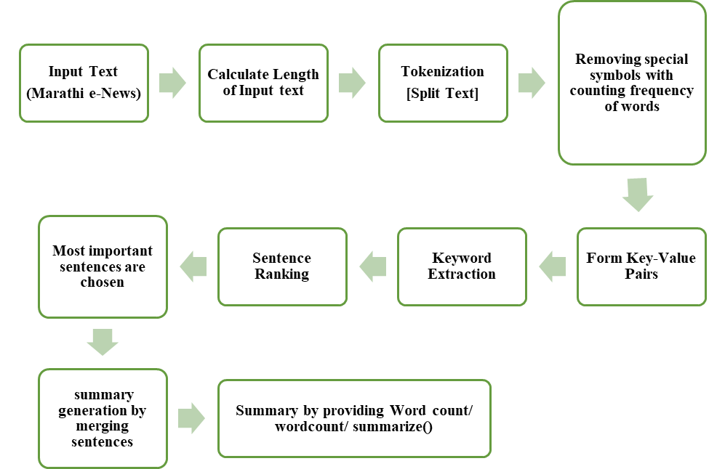

Fig 1. Proposed Methodology

- EXPERIMENTAL ANALYSIS &RESULTS

Table 1. Percentage of Accuracy
Domain | Total | positives | Negatives | Percentage
Banking
Sports
Film Industry
General Knowledge
Politics

- Conclusion
Text summarization (10 Times new Roman)

References
- R. Ceterchi, L. Zhang, K. G. Subramanian, and G. Zhang, “Hilbert words as arrays generated with P systems,” J Membr Comput, vol. 3, no. 3, pp. 163–169, 2021.
- M. Gheorghe, A. Păun, S. Verlan, and G. Zhang, “Membrane computing, power and complexity,” in Encyclopedia of Complexity and Systems Science, Berlin, Heidelberg: Springer Berlin Heidelberg, 2017, pp. 1–16.
- G. Wolf, J. S. Almeida, M. A. M. Reis, and J. G. Crespo, “Non-mechanistic modelling of complex biofilm reactors and the role of process operation history,” J. Biotechnol., vol. 117, no. 4, pp. 367–383, 2005.
- R. W. Farebrother, “Notes on the prehistory of principal components analysis,” J. Multivar. Anal., no. 104814, p. 104814, 2021.

