Title 24 Times new Roman

¹Axxxxxx, ²Syyyyyyy, ³Vzzzzzzzzzzz ( 10 Times new Roman Bold)
^{1,2,3} Vvvvvvvvvvvvv
¹adxxxxxx@gmail.com, ²soyyyyyyy@gmail.com, ³vxxxxxxxx@yahoo.co.in

ArticleInfo

Journal of Machine and Computing (http://anapub.co.ke/journals/jmc/jmc.html)

Doi : https://doi.org/10.53759/7669/jmcXXXXXXXX
Received xx December xxxx; Revised form xx December xxxx; Accepted xx December xxxx
Available online xx January xxxx.
©2022 The Authors. Published by AnaPub Publications.
This is an open access article under the CC BY-NC-ND license. (http://creativecommons.org/licenses/by-nc-nd/4.0/)

Abstract - The Text summarization (10 Times new Roman)

Keywords - Machine Learning approach, (10 Times new Roman)

INTRODUCTION
Text summarization (10 Times new Roman)

- WORK IN THIS AREA
(10 Times new Roman)
There are 2 ways to perform text summarization: first one is single document, and the other is multidocument, and the summarization further
Considering English language, a lot of work has been done and got enhanced results for summarizing it.

- PROPOSED METHODOLOGY
Text summarization (10 Times new Roman)

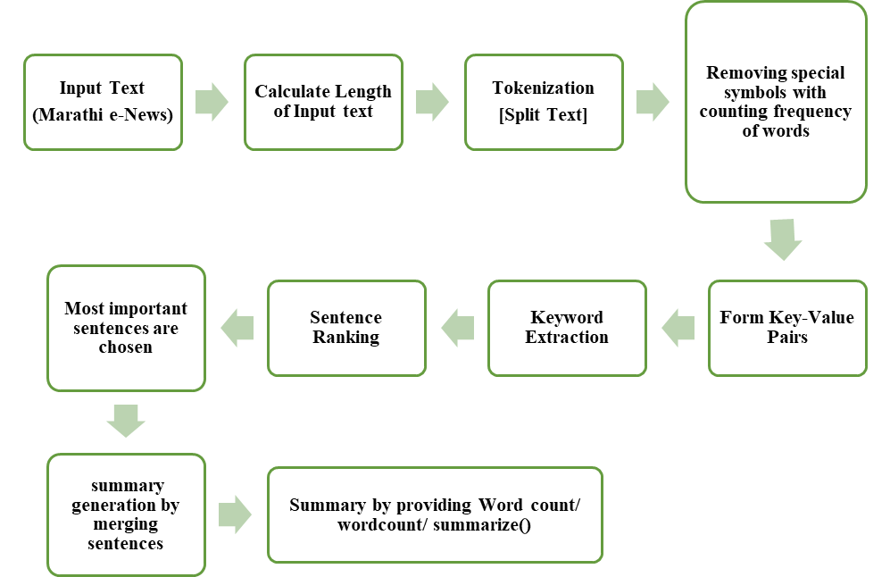

Fig 1. Proposed Methodology

- EXPERIMENTAL ANALYSIS &RESULTS

Table 1. Percentage of Accuracy
Domain | Total | positives | Negatives | Percentage
Banking
Sports
Film Industry
General Knowledge
Politics

- Conclusion
Text summarization (10 Times new Roman)

References
- R. Ceterchi, L. Zhang, K. G. Subramanian, and G. Zhang, “Hilbert words as arrays generated with P systems,” J Membr Comput, vol. 3, no. 3, pp. 163–169, 2021.
- M. Gheorghe, A. Păun, S. Verlan, and G. Zhang, “Membrane computing, power and complexity,” in Encyclopedia of Complexity and Systems Science, Berlin, Heidelberg: Springer Berlin Heidelberg, 2017, pp. 1–16.
- G. Wolf, J. S. Almeida, M. A. M. Reis, and J. G. Crespo, “Non-mechanistic modelling of complex biofilm reactors and the role of process operation history,” J. Biotechnol., vol. 117, no. 4, pp. 367–383, 2005.
- R. W. Farebrother, “Notes on the prehistory of principal components analysis,” J. Multivar. Anal., no. 104814, p. 104814, 2021.

